Software Requirements Specification
FITNESS WEBSITE

Table of Contents
- Introduction 3
  - Purpose 3
  - Scope 3
  - Overview 3
  - Need for the System 3
  - Similar Apps
- Functional Analysis 3
- Operational Scenario 6
- Other Features 8
- Interfaces with the Device 8
- Testing the application
- Sample Use Case 8
- Glossary 10
- Space for Updating Versions and Comments 10

Introduction

The following subsections of the Software Requirements Specifications (SRS) document provides an overview of the entire SRS.

Purpose
This document outlines the usage and implementation of the FITNESS website.

Document Conventions
This Document is created based on the IEEE template for System Requirement Specification Documents.

Scope
The website is mainly for those who plan to lose or gain weight and require a planned medium for the same. The intended audience of this document is anyone who needs a platform where they find a sustainable and clear plan with videos to lose/maintain/gain weight or stay healthy.

Overview
The website will initially take some inputs from the user whether he/she is interested in losing/maintaining/gaining muscle and some extra information regarding the same. Based on the inputs, the software will map the videos, diet and schedule them for the particular user.
Further, the website keeps track of the workouts and diet maintained by the user and gives him a score to assess his discipline.

Product Perspective
    - There are many apps/websites for tracking the running and daily activities of every individual.
    - However, each individual has a different need of either losing/maintaining/gaining the weight.
    - There are no apps/websites which address all these issues. Further, there are different apps/websites for diet control and schedule maker.
    - One has to install many apps or visit different websites to meet one unique goal.
    - In addition to suggesting the workouts, this FITNESS website also plans a schedule where every day's diet and videos related to the same are conveyed.

Similar Apps
Adidas Mi – Coach -
This app has a GPS based tracker for running. It also gives a score for individual's daily performance. It is a more robust and a well-designed app, but doesn't have features of conveying related videos of exercises and the diet plan.
Seven-7 Minute Workout Challenge-
This app has universal and scientifically approved exercises for maintaining the muscle. But the app has only 15 activities for 7 minutes, and the scoring is just based on them. As mentioned earlier, this too doesn't have the suggestion of videos and diet planner. Further, this app doesn't have the tracking feature too.

Functional Analysis

The website will be able to record exercises, repetitions and the diet followed.

Description : The website will have a calendar layout that the user will be able to click on a specific day where they can find all the events and diet scheduled for the day. Further, the activities will be monitored and recorded for the same date.

Implementation: A UI is created for the User to enter the repetitions of the exercises performed, diet followed for the day. Based on the given schedule and the followed schedule, website gives a score to the user for that day. The score will be a function of the repetitions mentioned by the website and the repetitions performed by the user. Similarly for the diet, calories intake and the calories mentioned by the website will effect the score.

Criticality : The feature is important because without this user will have no directions to proceed. This forms the heart of the website.

Risks : The user might enter the wrong data to top the chart and measures are to be taken to address the issue. Further, this may lead the app to suggest wrong and intense exercises which may affect the performance of the user and subsequently the app.

Dependency: It depends on the calendar part of the device. Without proper interface with the calendar part, it makes FITNESS website malfunction. Further, effectiveness of the accounting by the user also has impact on the performance.

The website will be able to suggest the videos, diet and schedule them on the calendar.

Description: The website will take the inputs from the user and suggest videos, diet and schedule for the user.

Implementation: A data base of the videos (can be from Youtube), is created. Based on the user inputs like what part of the body the user is focused on , the videos will be mapped. For a low data device case instead of the videos, thumbnails from the video at regular intervals can be mapped. Further, diet is also planned similarly.

Criticality: This is also an important feature because this is the main feature which is been absent in many of the available websites.

Risks: The scheduling of videos and diet based on the inputs of the users needs an effective algorithm. A very effective algorithm after a literature survey will be taken to address the issue.

Dependency: It relies on the information from Youtube . Instead a database collected from Youtube and stored in an external server would address the issue. However since Youtube is available free in near future it wouldn’t be a problem.

The website will be able to score the user globally to motivate the user.

Description: User will be ranked based on the score he/she has obtained and will be ranked globally in categories of daily and overall performance.

Implementation: The website will record the user's score and upload it to a global server where ranking is done based on all the users' performance which can be displayed to every user in the website itself under a unique category named Ranking. This will be done with only prior permissions from the user so that the privacy of the user is not affected. However even if the user is not interested in disclosing his identity, ranking can be displayed with some random comic names.

Criticality: This is also an add-on kind of feature. It is a motivation for the user to be more discipline towards the workouts and diet.

Risks: The fake accounting might effect the chart. Inorder to avoid the fake accounting by the users only the data with feasible results is accounted while ranking the user.

Dependency: Segregation of correct and incorrect data depends on the algorithm. The algorithm hence decides the function of the website.

Operational Scenario

First Time Enrollment:
- User opens the website.
- User enrolls the name and personal details.
- User chooses if he/she wants to lose/maintain/gain muscle.
- User will be given a choice whether he/she is interested in shaping up specific body parts/or whole body activity .
- User will be asked for whether he/she is beginner/intermediate/Pro so that the application decide the videos based on the inputs.
- Based on the user information, the website maps the videos, diet and sorts them according to schedule.
- Website finally suggests a plan.

Daily Activities:
- User can look at the videos scheduled for the day and follow the mentioned workout.
- User has to follow the diet plan.
- At the end of the day, user will be accounting for all his daily activities.
- Some of them (say exercises) will be automated while doing the activity itself.
- The others like diet are accounted at the end of the day. User is trusted to during this process for a successful schedule.
- The website gives a score for the day and suggests/re-schedules the plan based on the daily activity.
- Further, a global score is provided for the user to motivate him.

Database Mapping:
- Server will have a collection of videos and each video will be labelled with many categories.
- When a user requests for videos with specified categories, videos which map to the categories mentioned by user will be sorted out.
- Similarly diet related to the categories is also data based and based on the users input they are also sorted out respectively.
- Now based on user’s requirement schedule for a week/month will be planned and displayed on calendar.
- Further while mapping user input data during usage of website will be segregated based on their age and sex. This ensures proper functioning of a mapping algorithm.
- Reviews and feedback from the users also segregated based on age and sex.

Improving the Database:

- With evolution of the website and usage of the website by users data base will be re-mapped.

- Users will give rating to the exercises and based on the ratings the remapping will be done. This helps in improving the performance of the website with the usage.

- Further, the rating can be displayed to the user which allows him to choose among many of the available videos. This ensures the quality of the videos available in the website.

- The mentioned feature can be added as a commercial element where only premium users can have access to the ratings. Thus the review and the feedback of the users will be used efficiently in this way.

Notify:

Other Features

  - The user will be reminded using the in built notification option in the website about his work out or schedule.
  - Further, if user permits, the diet can also be notified at regular intervals whenever he/she browse the internet.
  - This adds as an extra feature for the website. The turn on and off feature will be given to let the users customize the website based on their requirements.

Privacy
- The website will not disclose any personal information of the customers.
- Even in the global rankings the other user names will not be displayed unless the user wishes to do so.
- Further, the website will give access based on secured authorization.
- The authorization can be linked with the device which the user will be operating while doing the workouts.
- Encryption of data will be implemented which will ensure that without the encrypted key unauthorized access of data impossible.

Version
- The website will receive feedbacks in a separate category where a user can comment on the crash of the website, malfunctioning of the website.
- This will be collected and will be updated in the next versions.
- Further, with every version the changes will be logged. However each version should support roll back of the website.

Playlist
- The website will have a playlist which is linked to youtube .
- This helps the user to push him during the work outs.
- User will be given choice of the playlist linked to youtube .
- Since youtube is an open source kind of platform, no extra cost will be involved. Further users will have access to a wide range of music.

Advantage of having a Web Access :
- Devices like mobile happen to be in smaller size and viewing the videos will be difficult things some times.
- A web access to every account helps the user to organize the things in a well-planned manner and track the things.
- User can have very clear and precise analysis through videos in a web based platform.
- Later during his workouts he will have the device where he can chose the already viewed videos.

Compatibility
- The website should take a maximum of 1 GB of storage [ROM].
- The website should not exceed a window size of the screen resolution.
- Website shall be compatible with any updated version of Windows.

Demo
- Demo of using the website should be available during the first time access of the website. This will be in form of short video and a document.
- Further this feature will be made as an option in the menu of the website.

5. Interfaces With the Device

Hardware:
- System Screen.
- System Clock: For notification and the time calculations during the workout, the website will use the system clock.

Software:
Internet: Website will use the internet data and may cost the user for the same. However, user can opt out this.

6 .Testing the Application

Testing Process
- The website will be tested with in a University . A university with professors and students, with sufficient male and female users will form a diverse test case.
- Users will be allowed to use the website for a month, where they input their daily activities and rate the videos.
- The website will update suggesting based on the feedback of the users in that span of testing period.
- A website review will be taken at the end of the testing duration.
- Any malfunctions and the crashes of the website will be noted and sorted out.
- During the process , server functioning and algorithm will also be evaluated.
- Algorithm of mapping, if not efficient will be tweaked based on the user suggestions.
- Further, during the testing stage, users will be allowed to suggest on what else would make the website better.

Sample Use Case
Figure 1 presents a sample use case of a user and the choices/menu options he/she will have. Figure 2 presents the activities to be performed by the application.

Figure 1. User Case

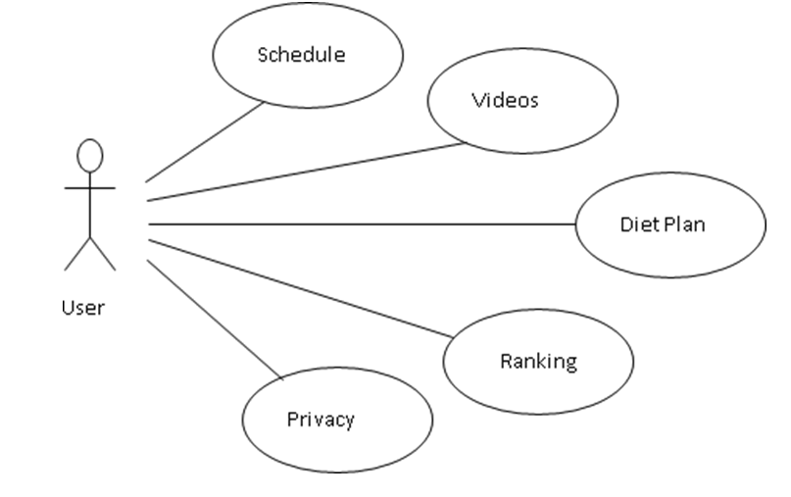

Figure 2. Website Case

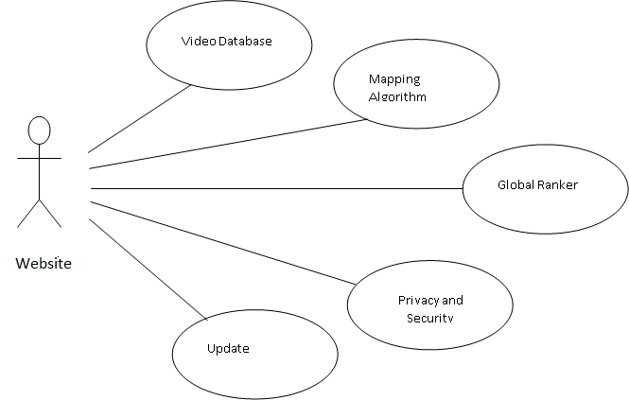

Glossary

Acronym | Expansion
ROM | Random Only Memory
MB | Mega Bytes
UI | User Interface
OS | Operating System

Change Log:

Space for Updating Versions and Comments

Version Number | Removed Features | Added Features
0.0.1 | - | -

Useful Links-

Link to the website –
Other links related to website -

